Nagarro – eClaims

DAR Document – ECS v/s EKS

Nagarro Software Pvt. Ltd.
Utsav Verma

Revision History
Version | Date | Author/Contributor | Comments
1.0 | 20/8/2026 | Utsav Verma | Initial draft

Contents
1 Introduction 4
1.1 Objective and scope of the document 4
2 Requirements at a Glance 5
3 Available tools 6
3.1 Amazon Elastic Container Service 6
3.1.1 Features 6
3.1.2 Pricing 7
3.2 Amazon Elastic Kubernetes Service 9
3.2.1 Features 9
3.2.2 Pricing 10
4 Comparison Analysis 11
4.1 Weightage Matrix 11
4.2 Comparison 12
5 Recommendation 12
6 Assumptions 13
7 Risks 14
8 Appendix 15
8.1 References 15

Introduction
The DAR furnishes exhaustive insights into the pivotal components essential for crafting our deployment strategies. Through the utilization of this document, our objective is to discern the optimal deployment avenue between Amazon ECS (Elastic Container Service) and Amazon EKS (Elastic Kubernetes Service).
This report is intricately crafted to delineate the indispensable requisites for deploying our applications. Serving as a guiding beacon, it offers comprehensive information on vital aspects such as infrastructure requirements, scalability parameters, resource utilization patterns, operational complexities, and anticipated cost projections.

Objective and scope of the document
Our objective is to scrutinize the DAR to assess the degree of alignment between each deployment option and our specified requirements. We will meticulously evaluate factors such as the complexity of our applications, scalability requirements, operational simplicity, cost-effectiveness, and level of control over resources. Through this comprehensive analysis, we aim to arrive at an informed decision regarding whether Amazon ECS or Amazon EKS is better suited to our deployment needs.
This evaluation will facilitate a thorough examination of the strengths and limitations inherent in each deployment option vis-à-vis our unique deployment prerequisites. Ultimately, it will serve as a compass, guiding us toward selecting the most suitable strategy that harmonizes with our application's architecture, operational preferences, and overarching business objectives

Requirements at a Glance

Before we dive into development, it's crucial to definitively select our application's deployment strategy. This proactive decision-making process will set the tone for our development endeavors, ensuring alignment with the chosen deployment approach from the outset.
Choosing the most suitable deployment option upfront is key to steering the development trajectory in the right direction. It allows us to lay the groundwork, establish architecture, and implement development practices that cater specifically to the selected deployment method—whether it's Amazon ECS (Elastic Container Service) or Amazon EKS (Elastic Kubernetes Service).
By making this preliminary decision, we aim to sidestep potential setbacks or the need for significant architectural adjustments during later stages of development. This proactive approach ensures that our development efforts are optimized and synchronized with the chosen deployment option, fostering efficiency, consistency, and better resource utilization from the project's inception.

Available tools
- Amazon ECS (Elastic Container Service)
- Amazon EKS (Elastic Kubernetes Service)

Amazon Elastic Container Service
Amazon ECS (Elastic Container Service) is a fully managed container orchestration service offered by Amazon Web Services (AWS). It provides a platform for deploying, managing, and scaling containerized applications using Docker containers.
With ECS, developers can easily package their applications into containers and deploy them onto a cluster of virtual servers (EC2 instances) or utilize AWS Fargate for serverless container deployment. ECS handles the management of underlying infrastructure, including provisioning, scaling, and load balancing, allowing developers to focus on building and managing their applications.
ECS integrates seamlessly with other AWS services such as Elastic Load Balancing (ELB), Amazon VPC (Virtual Private Cloud), AWS IAM (Identity and Access Management), AWS CloudFormation, and AWS CloudWatch, enabling developers to build scalable and resilient architectures.
Overall, Amazon ECS provides developers with a reliable and scalable platform for deploying containerized applications, streamlining the development and deployment process in cloud environments.

Features
Here are some key features and characteristics of Amazon ECS:
- Fully Managed Service
- Container Orchestration
- Integration with AWS Services
- Flexible Deployment Options
- Scalability
- Security and Compliance
- Cost-Effective
- Load Balancing
- Scheduling

Pricing
Amazon Elastic Container Service (ECS) is purpose-built to help you run your architecture in an efficient, automated, and scalable manner. There is no additional charge for Amazon ECS. You pay for AWS resources (for example, Amazon Elastic Compute Cloud [Amazon EC2] instances or Amazon Elastic Block Store [Amazon EBS] volumes) you create to store and run your application. You only pay for what you use, as you use it; there are no minimum fees and no upfront commitments.
There are three different charge models for Amazon ECS:
- AWS Fargate Launch Type Model: With AWS Fargate, you pay for the amount of vCPU and memory resources that your containerized application requests. vCPU and memory resources are calculated from the time your container images are pulled until the Amazon ECS Task terminates, rounded up to the nearest second. A minimum charge of one minute applies
- Amazon EC2 Launch Type Model: There is no additional charge for Amazon EC2 launch type. You pay for AWS resources (such as Amazon EC2 instances or Amazon EBS volumes) you create to store and run your application. You only pay for what you use, as you use it; there are no minimum fees and no upfront commitments.
- Amazon ECS on AWS Outposts: Amazon ECS on AWS Outposts pricing is simple and works the same as it does in the cloud: the Amazon ECS control plane is in the cloud (not on Outposts) and your container instances run on the Outposts EC2 capacity at no additional charge.
For our use case, we’ll have to use EC2 Launch Type, which again has three different purchase models
- On-Demand: On-Demand Instances let you pay for compute capacity by the hour or second with no long-term commitments. This frees you from the costs and complexities of planning, purchasing, and maintaining hardware and transforms what are commonly large fixed costs into much smaller variable costs.
On-Demand Instances are recommended for:
  - Users that prefer the low cost and flexibility of EC2 without any upfront payment or long-term commitment
  - Applications with short-term, spiky, or unpredictable workloads that cannot be interrupted.
  - Applications being developed or tested on EC2 for the first time.
- Savings Plans: Savings Plans are a flexible pricing model that can help you reduce your bill by up to 72% compared to On-Demand prices, in exchange for a commitment to a consistent amount of usage (measured in $/hour) for a 1- or 3-year term.
AWS offers three types of Savings Plans: Compute Savings Plans, EC2 Instance Savings Plans, and Amazon SageMaker Savings Plans. Compute Savings Plans apply to usage across Amazon EC2, AWS Lambda, and AWS Fargate.
Savings Plans are recommended for:
  - Committed and steady-state usage
  - Users looking to take advantage of the latest compute offerings while continuing to save money.

- Spot Instances: Amazon EC2 Spot Instances let you take advantage of unused EC2 capacity in the AWS cloud and are available at a discount of up to 90% compared to On-Demand prices.
Spot Instances are recommended for:
  - Fault-tolerant or stateless workloads
  - Applications that can run on heterogeneous hardware
  - Applications that have flexible start and end times
Actual Pricing for EC2 Launch type with on-demand capacity:
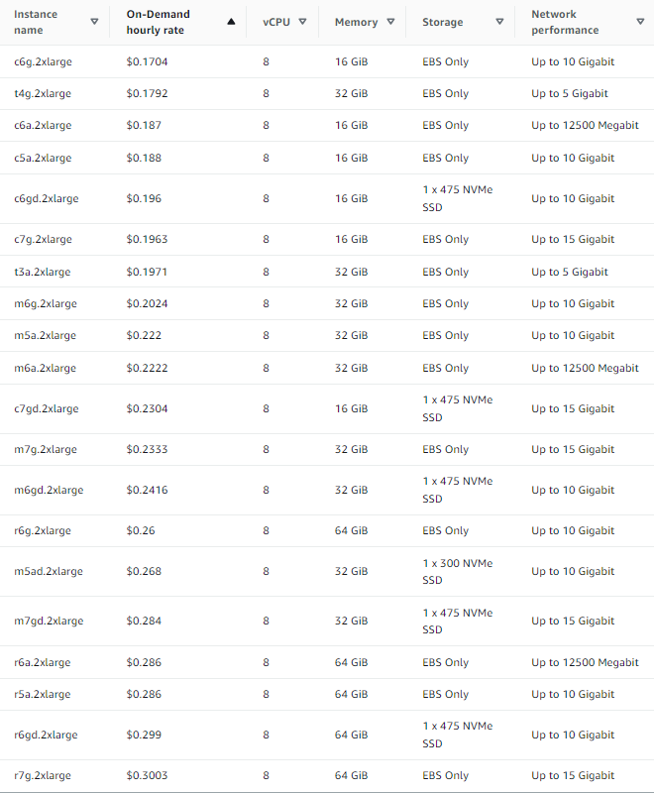

Amazon Elastic Kubernetes Service
Amazon Elastic Kubernetes Service (Amazon EKS) is a managed Kubernetes service that makes it easy for you to run Kubernetes on AWS and on-premises. Kubernetes is an open-source system for automating deployment, scaling, and management of containerized applications. Amazon EKS is certified Kubernetes-conformant, so existing applications that run on upstream Kubernetes are compatible with Amazon EKS.
Amazon EKS automatically manages the availability and scalability of the Kubernetes control plane nodes responsible for scheduling containers, managing application availability, storing cluster data, and other key tasks.
Amazon EKS lets you run your Kubernetes applications on both Amazon Elastic Compute Cloud (Amazon EC2) and AWS Fargate. With Amazon EKS, you can take advantage of all the performance, scale, reliability, and availability of AWS infrastructure, as well as integrations with AWS networking and security services, such as application load balancers (ALBs) for load distribution, AWS Identity and Access Management (IAM) integration with role-based access control (RBAC), and AWS Virtual Private Cloud (VPC) support for pod networking.

Features
Here are some key features of Amazon EKS:
- Managed Kubernetes Clusters
  - Managed Control Plane
  - Service Integrations
  - Hosted Kubernetes Console
  - EKS Add-Ons
  - Managed Node Groups
- Hybrid Deployments
- Use eksctl for launching nodes and single line management.
- Networking and Security
  - Support for IPv6
  - EKS Pod Identity
  - Service Discover
  - Service Mesh
  - VPC Native Networking
  - AWS IAM Authenticator
  - IAM for Service Accounts
  - Compliance
  - Container Image Signature Verification
- Load Balancing
- Serverless Compute
- Cost monitoring
  - Cost allocation tagging
  - Kubecost
- Logging
- Certified Conformant
- Managed Cluster Updates
- Advanced Workload Support
- Open-Source Compatibility
- EKS Connector

Pricing
Amazon Elastic Kubernetes Service (Amazon EKS) gives you the flexibility to start, run, and scale Kubernetes applications in the cloud or on-premises. Amazon EKS provides highly available and secure clusters while automating key tasks such as patching, node provisioning, and updates.
You pay $0.10 per hour for each Amazon EKS cluster that you create. You can use a single EKS cluster to run multiple applications by taking advantage of Kubernetes namespaces and IAM security policies. You can run EKS on AWS using either Amazon Elastic Compute Cloud (Amazon EC2) or AWS Fargate, and on-premises using AWS Outposts.
If you are using Amazon EC2 (including Amazon EKS managed node groups), you pay for AWS resources (e.g., EC2 instances, Amazon Elastic Block Store (EBS) volumes, Outposts capacity) you create to run your Kubernetes worker nodes. You only pay for what you use, as you use it; there are no minimum fees and no upfront commitments. See detailed pricing information on the Amazon EC2 pricing page and AWS Outposts rack pricing page.
- Amazon EKS Extended support for Kubernetes versions: With Extended support for Kubernetes versions in Amazon EKS, you can now run Amazon EKS clusters on a Kubernetes version for up to 26 months from the time the version is generally available on Amazon EKS. You will be charged $0.60 per hour for each Amazon EKS cluster that is running on a Kubernetes version covered under extended support. The $0.60 per cluster per hour is inclusive of the $0.10 per cluster per hour you pay for Amazon EKS clusters.
- Amazon EKS on AWS Fargate: If you are using AWS Fargate, pricing is calculated based on the vCPU and memory resources used from the time you start to download your container image until the Amazon EKS pod terminates, rounded up to the nearest second. A minimum charge of one minute applies. See detailed pricing information on the AWS Fargate pricing page.
- Amazon EKS on AWS Outposts: Amazon EKS on AWS Outposts pricing is simple and works the same as it does in the cloud: You pay $0.10 per hour per cluster for the Amazon EKS service. This applies to both extended and local cluster deployment options. The Amazon EKS service fee is not included in the Outposts pricing. Please refer to the AWS Outposts rack pricing page for details on Outpost capacity pricing.
For our use case here are the calculations for the cluster (excluding cost of instance),

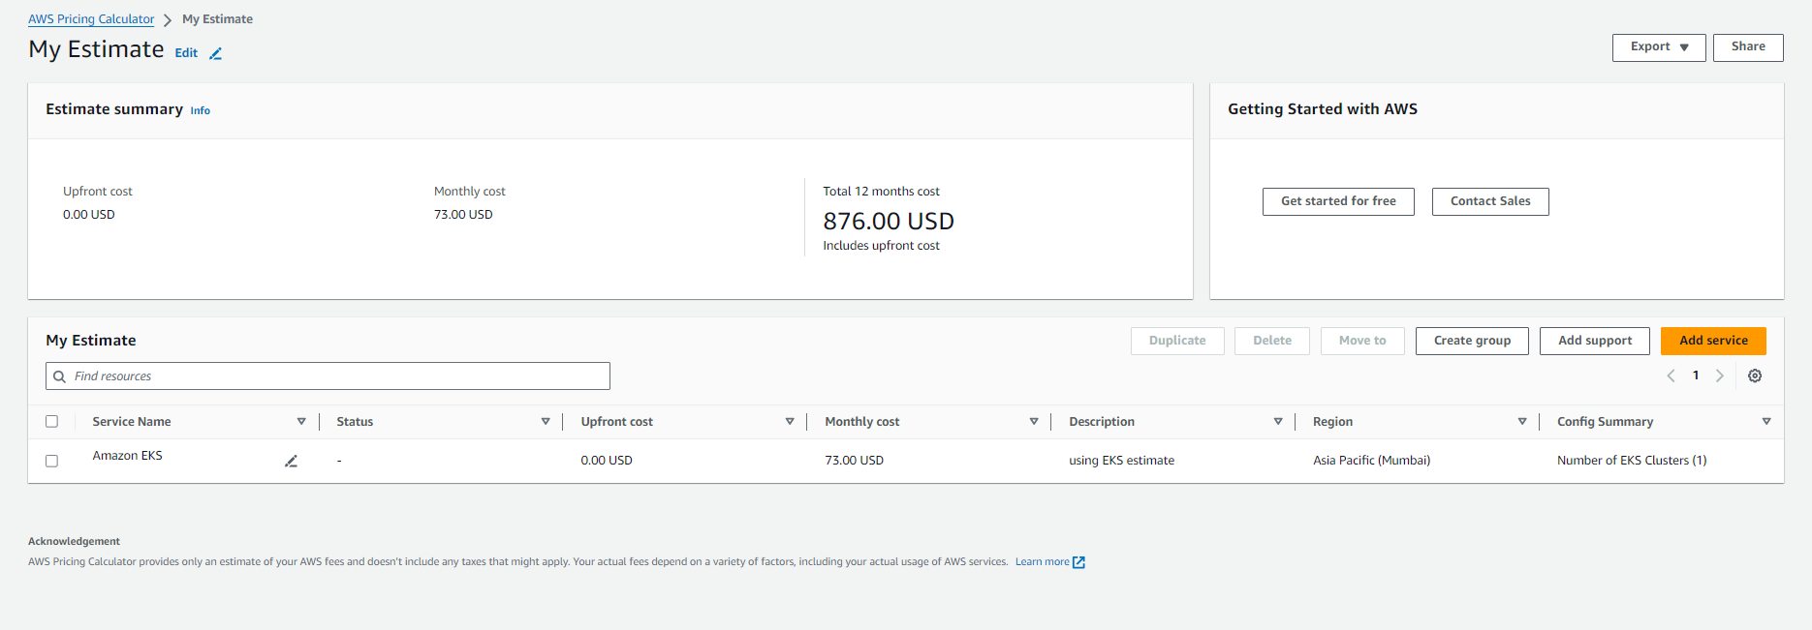

Comparison Analysis
When comparing AWS ECS (Elastic Container Service) with Amazon EKS (Elastic Kubernetes Service), several factors come into play, including ease of use, scalability, flexibility, and cost. Here's a comparison:
 | AWS ECS | AWS EKS
Cost | Less; Only EC2 cost | More; Includes both EC2 as well as cluster cost
Ease of Use | Simple and easy to use | Requires an understanding about Kubernetes
Maintainability | Fully managed AWS service | Abstracted Kubernetes service without managing cluster  Kubernetes-as-a-service
Flexibility | Flexible in terms of deployment, use EC2 or AWS Fargate | Felxibility in terms of workload orchestration
Security | Amazon ECS is deeply integrated with IAM, Secrets Manager | Use of IAM roles for service accounts, using namespaces and third party solutions for managing secrets
Portability | Can be ported with a small migration effort and cost | Greater degree of portabilty, can be ported to run on any Kubernetes infra
Scaling | AutoScalingGroup | HorizontalPodAutoscaler
Community | Growing community | Benefits from the Kubernetes ecosystem
Control | Less control | More control
Resource utilization | Efficient by utilizing the same instance | more granular control, scheduling, resource request, limits, etc
Monitoring and Logging | Effective logging | Effective logging
Learning curve | Less | Deeper learning curve

Weightage Matrix

Feature | Points
Cost | 5
Maintainability | 4
Flexibility | 5
Security | 3
Portability | 5
Control | 3
Complexity | 4

Comparison

Feature | AWS ECS ✓ | AWS EKS
Cost | 5 | 3
Maintainability | 5 | 4
Flexibility | 5 | 4
Portability | 3 | 5
Security | 5 | 4
Control | 3 | 5
Complexity | 5 | 3

Recommendation
The comparison above strongly suggests utilizing ECS over EKS for our container orchestration and deployment needs. Opting for ECS offers distinct advantages in our specific use case, including reduced costs and improved resource efficiency.
While EKS provides enhanced portability and control, the decision to prioritize ECS is rooted in several factors. Firstly, the migration cost from Amazon ECS to alternative platforms, such as Azure's ACS, is significantly lower compared to the comprehensive costs associated with EKS. Given that such migrations are infrequent occurrences, the long-term cost savings outweigh the potential benefits of EKS.
Moreover, dedicating resources specifically for cluster management is not deemed essential in our scenario. Hence, the pragmatic choice is to favor ECS over EKS for our deployment strategy.

Assumptions
- Migration cost for ECS < Management cost for a EKS cluster
- Cost and efficient resource utilization to be considered
- Data should persist
- Auto scaling groups and load balancers to be used.
- Performance will be same with both EKS and ECS

Risks
- Traceability
- Event Source Dependencies
- Error handling
- Metrics and Alarms need to be available for proper usage of resources.
- Event order and sequencing
- Admin user (role) has to manually set the scaling limits.
- Retries need to be available

Appendix

References
- https://www.stormit.cloud/blog/aws-ecs-vs-eks/
- https://lumigo.io/aws-ecs-understanding-launch-types-service-options-and-pricing/ecs-vs-eks-5-key-differences-and-how-to-choose/#:~:text=The%20main%20difference%20in%20pricing%20between%20the,need%20to%20run%20numerous%20clusters%20on%20Amazon.
- https://www.techtarget.com/searchcloudcomputing/tip/Compare-Amazon-ECS-vs-EKS
- https://www.missioncloud.com/blog/amazon-ecs-vs-eks-which-service-is-right-for-you
- https://aws.amazon.com/eks/pricing/
- https://aws.amazon.com/ecs/?nc2=h_ql_prod_ct_ecs
- https://aws.amazon.com/eks/eks-anywhere/?nc2=h_ql_prod_ct_eksa
- Open AI: ChatGPT

